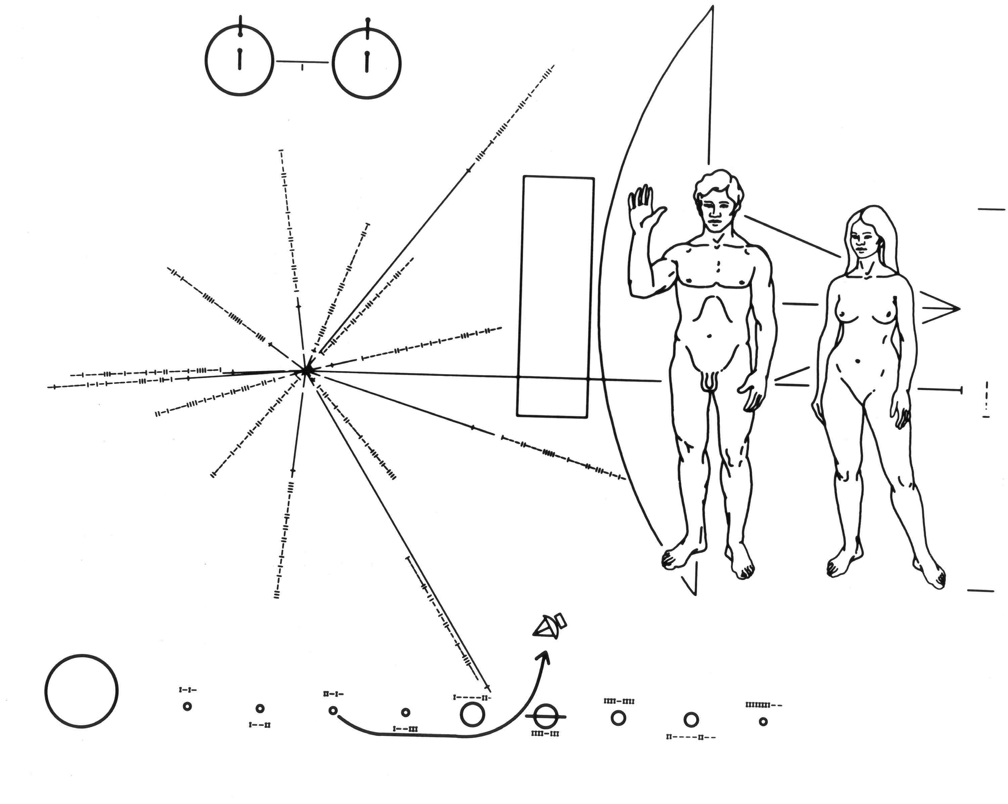
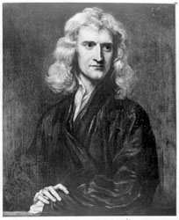
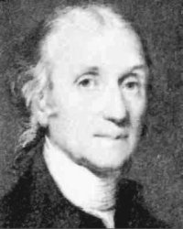
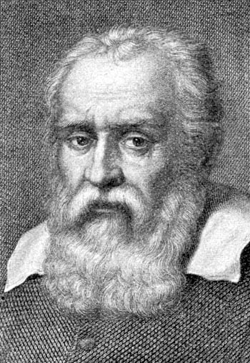
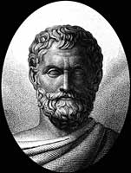
staple
Classical Mechanics
Eratosthenes
Galileo
Newton
Cavendish
Name ____________________________

Period ____
Date _____
and the Renaissance
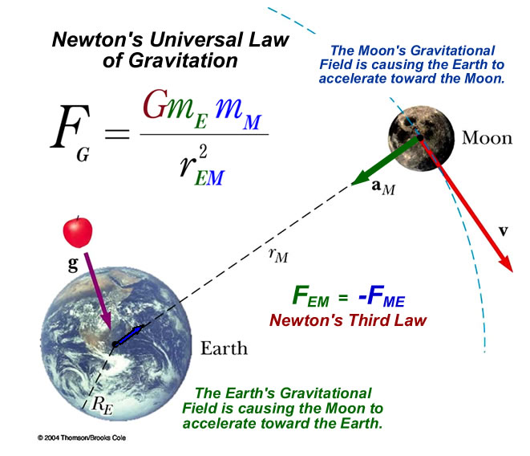
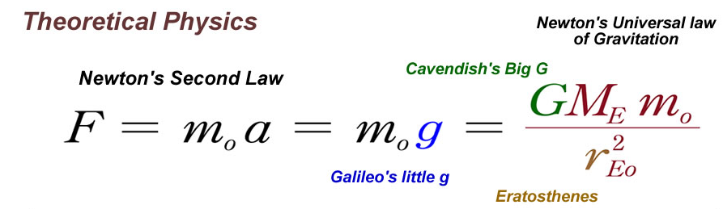
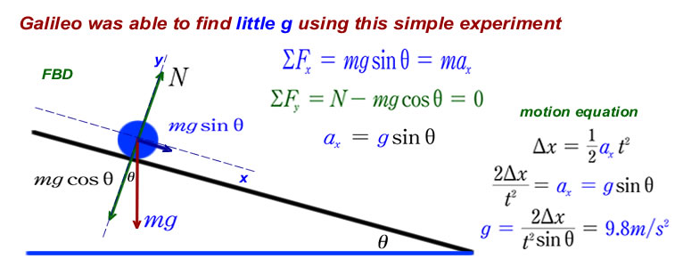
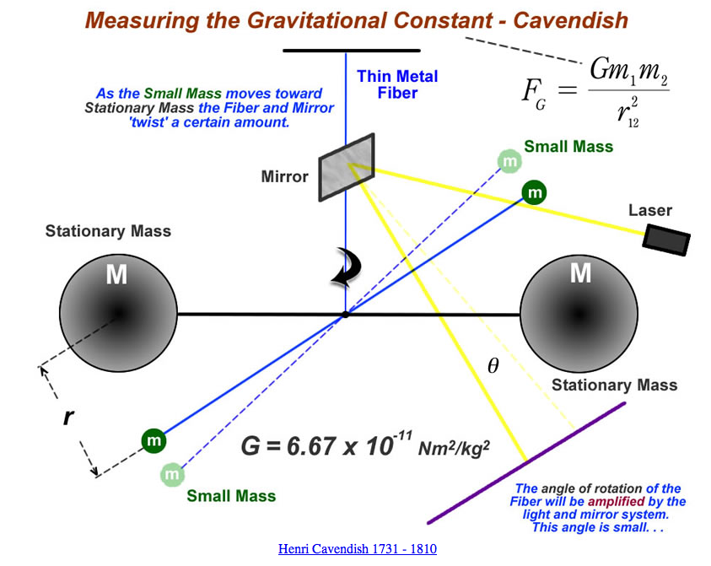
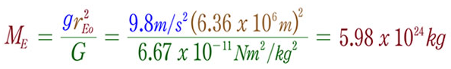
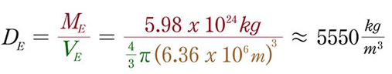
Name _______________________________
Date _______
Period ______
Now, calculating the Density of the Earth
Solving for the Mass of the Earth (ME)
Teacher’s Notes
a
b
c
d
e
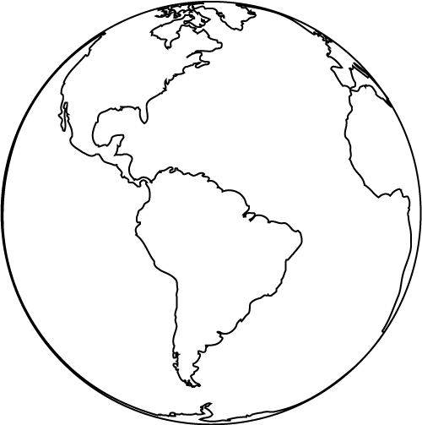
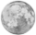
Name _______________________________
Date _______
Period ______
a
b
c
d
e
= = =
Newton’s Universal
Law of Gravitation
= = =
= = =
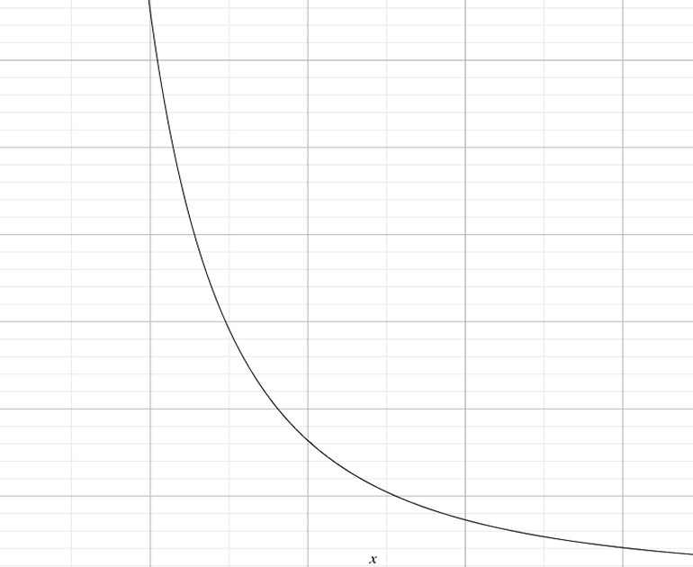

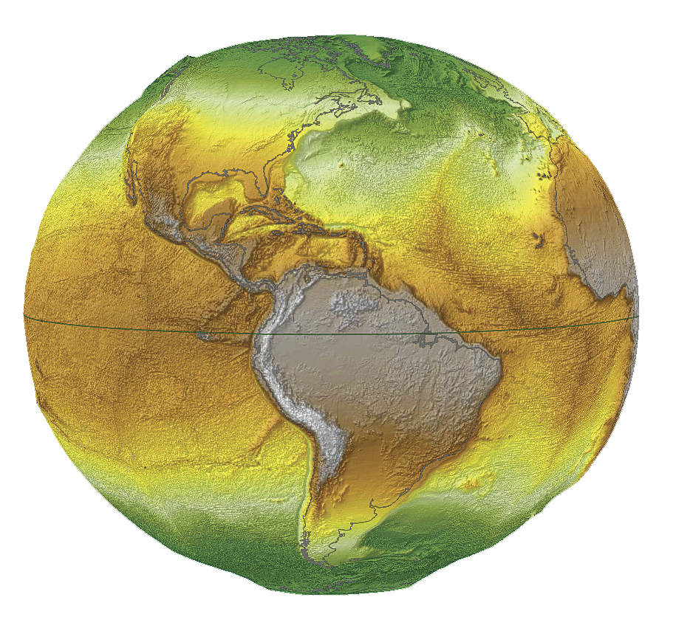
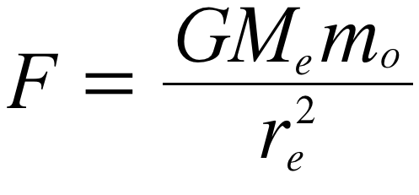
Force on Astronaut(N)
Distance from the center of the Earth (km)
F = ______ N
F = ______ N
F = ______ N
400
300
200
100
6400
12800
19200
25600
re = 6400 km
m = 67.35 kg
F = ______ N
660
165
73.3
41.3
600
500
Teacher’s Notes
1r
2r
3r
4r
0.5r
3200
Gravitational Force

Name ___________________________
Pe
Gravitational Force
m = 67.35 kg
F = ______ N
F = ______ N
F = ______ N
F = ______ N
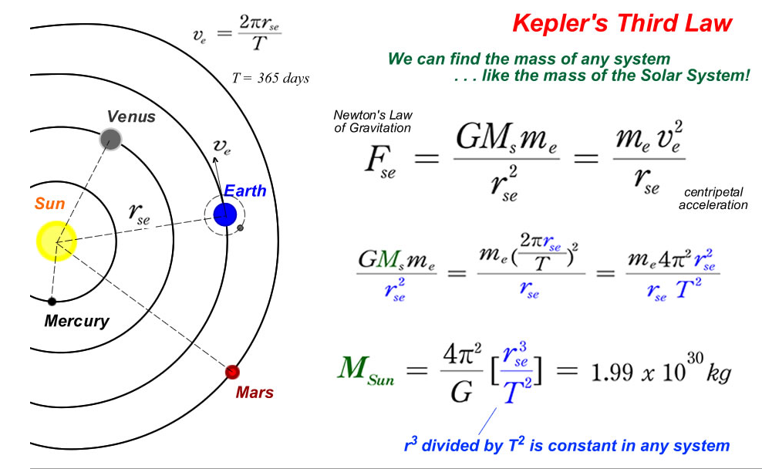
Teacher’s Notes

Kepler’s Third Law
= =
= =
= =
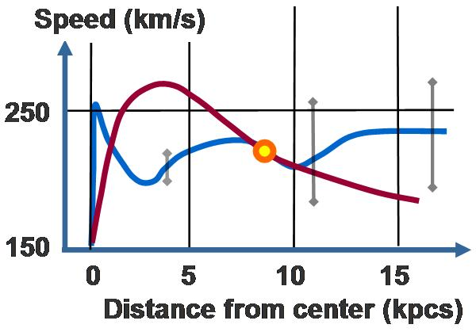
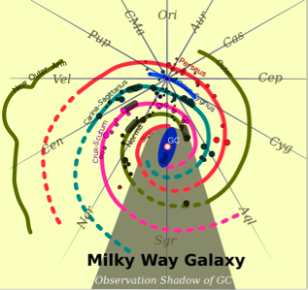
The stellar disk of the Milky Way Galaxy is approximately 100,000 light-years (9×10¹⁷ km) in diameter, and is considered to be, on average, about 1,000 ly thick. It is estimated to contain at least 200 billion stars and possibly up to 400 billion stars, the exact figure depending on the number of very low-mass, or dwarf stars, which are hard to detect, especially more than 300 light years from our sun, and so current estimates of the total number remain highly uncertain. This can be compared to the one trillion (10¹²) stars of the neighboring Andromeda Galaxy.
The Sun (and therefore the Earth and the Solar System) may be found close to the inner rim of the galaxy's Orion Arm, in the Local Fluff inside the Local Bubble, and in the Gould Belt, at a distance of ~25,000±1,000 ly from the Galactic Center. The Sun, and thus the Solar System, is found in the galactic habitable zone.
The Milky Way Galaxy
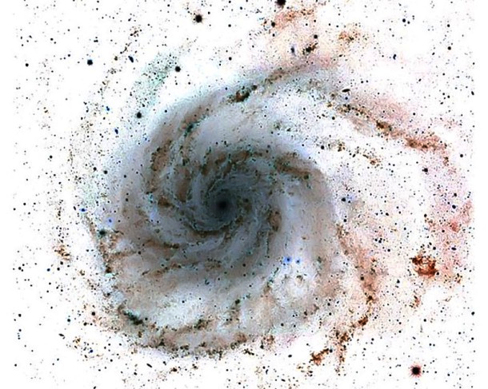
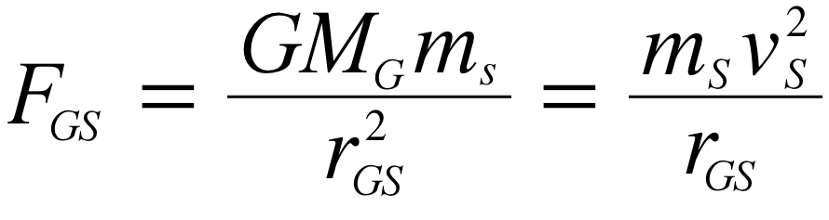
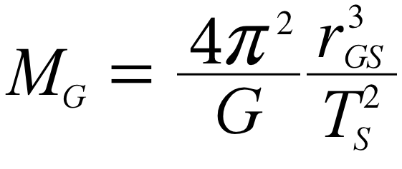
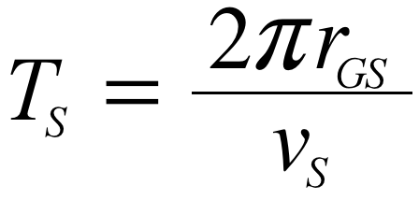
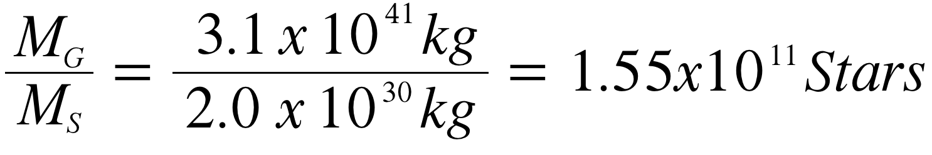
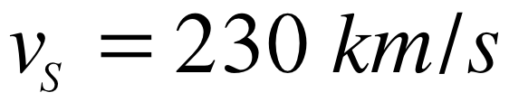
The Milky Way Galaxy
Name ____________________________
Period _______
Solar System
distance to center = 35,000 light-years
Kepler’s Law
Newton’s Universal Law of Gravitation
Period of the Solar System
Speed of the Solar System
Teacher’s Notes
The Milky Way Galaxy
Name ____________________________
Period _______
=
=
=
=
=
=
=
=
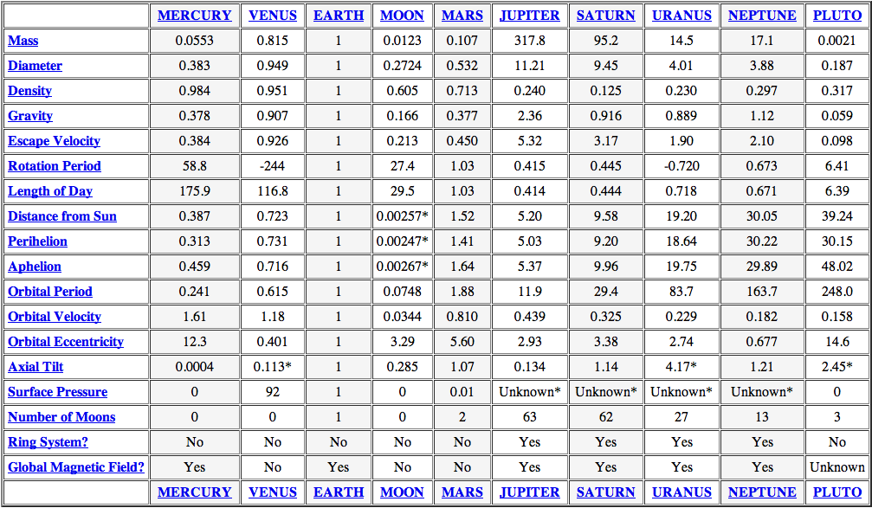
Planet Parameters in terms of the Earth
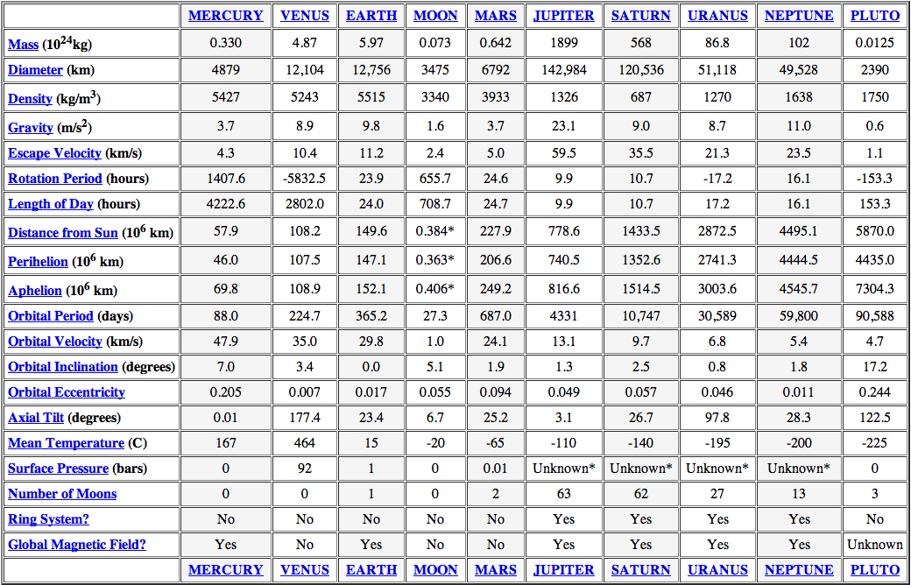
Planet Parameters

Using the Planet’s numbers, calculate the mass of the Sun.
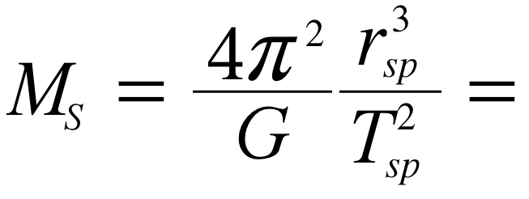
Using the Planet’s numbers, calculate the mass of the Sun.
Mercury
Venus
Earth
Mars
Jupiter
Saturn
Uranus
Neptune
Name ____________________________
Period _______


